Project Planning Phase
Project Planning Template (Product Backlog, Sprint Planning, Stories, Story points)

Date | 25 October 2026
Team ID | [Enter Team ID]
Project Name | Electric Vehicle Market Performance & Insights
Maximum Marks | 8 Marks

Product Backlog, Sprint Schedule, and Estimation (4 Marks)
Use the below template to create product backlog and sprint schedule
Sprint | Functional Requirement (Epic) | User Story Number | User Story / Task | Story Points | Priority | Team Members
Sprint-1 | Data Collection & Extraction | USN-1 | Download EV Market train/test CSVs from Kaggle and connect to Tableau (200,000 rows × 37 columns). | 5 | High | Rajlaxmi Pandey
Sprint-1 | Data Collection & Extraction | USN-2 | Explore schema, data types, set geographic role for manufacturing_country. | 3 | High | Rajlaxmi Pandey
Sprint-1 | Data Preparation | USN-3 | Remove duplicate vehicle_id, trim text, impute nulls with group medians, flag imputed rows (Python). | 8 | High | Rajlaxmi Pandey
Sprint-1 | Data Preparation | USN-4 | Create derived columns (segment, price/range/rating bands, revenue, range per kWh). | 4 | Medium | Rajlaxmi Pandey
Sprint-2 | Data Visualizations | USN-5 | Annual sales by category bar chart and Top-10 manufacturers by market share. | 5 | High | Rajlaxmi Pandey
Sprint-2 | Data Visualizations | USN-6 | KPI summary, battery-type pie chart, range by battery type bar. | 5 | High | Rajlaxmi Pandey
Sprint-2 | Data Visualizations | USN-7 | Sales trend by model year, range by category, manufacturing-country map. | 5 | Medium | Rajlaxmi Pandey
Sprint-2 | Data Visualizations | USN-8 | Customer-rating heatmap (category × battery type). | 5 | Medium | Rajlaxmi Pandey
Sprint-3 | Dashboard | USN-9 | Design 'EV Market Executive Overview' dashboard layout with KPI, charts and legends. | 8 | High | Rajlaxmi Pandey
Sprint-3 | Dashboard | USN-10 | Add filters (% of Total Annual Sales, Battery Type) and highlight interactions. | 4 | High | Rajlaxmi Pandey
Sprint-3 | Story | USN-11 | Build Story 1 with 5 captioned story points. | 8 | High | Rajlaxmi Pandey
Sprint-4 | Performance Testing | USN-12 | Measure data rendered, filters, calculated fields, visual count; optimise extract. | 5 | Medium | Rajlaxmi Pandey
Sprint-4 | Web Integration | USN-13 | Publish to Tableau Public; embed views in Flask app (Home/Dashboard/Story/About). | 7 | High | Rajlaxmi Pandey
Sprint-4 | Project Demonstration & Documentation | USN-14 | Push code & docs to GitHub, write report, record demo video. | 8 | High | Rajlaxmi Pandey

Project Tracker, Velocity & Burndown Chart: (4 Marks)
Sprint | Total Story Points | Duration | Sprint Start Date | Sprint End Date (Planned) | Story Points Completed (as on Planned End Date) | Sprint Release Date (Actual)
Sprint-1 | 20 | 4 Days | 18 Oct 2026 | 21 Oct 2026 | 20 | 21 Oct 2026
Sprint-2 | 20 | 4 Days | 22 Oct 2026 | 25 Oct 2026 | 20 | 25 Oct 2026
Sprint-3 | 20 | 4 Days | 26 Oct 2026 | 29 Oct 2026 | 20 | 29 Oct 2026
Sprint-4 | 20 | 4 Days | 30 Oct 2026 | 02 Nov 2026 | 20 | 02 Nov 2026

Velocity:
Our project has 4 sprints of 4 days each and the team (individual project) completes 20 story points per sprint. Average Velocity (AV) = Sprint velocity ÷ Sprint duration = 20 ÷ 4 = 5 story points per day. Total = 80 story points delivered over 16 days (18 Oct – 02 Nov 2026).
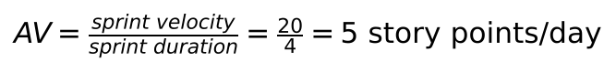

Burndown Chart:
A burn down chart is a graphical representation of work left to do versus time. It is often used in agile software development methodologies such as Scrum. However, burn down charts can be applied to any project containing measurable progress over time.
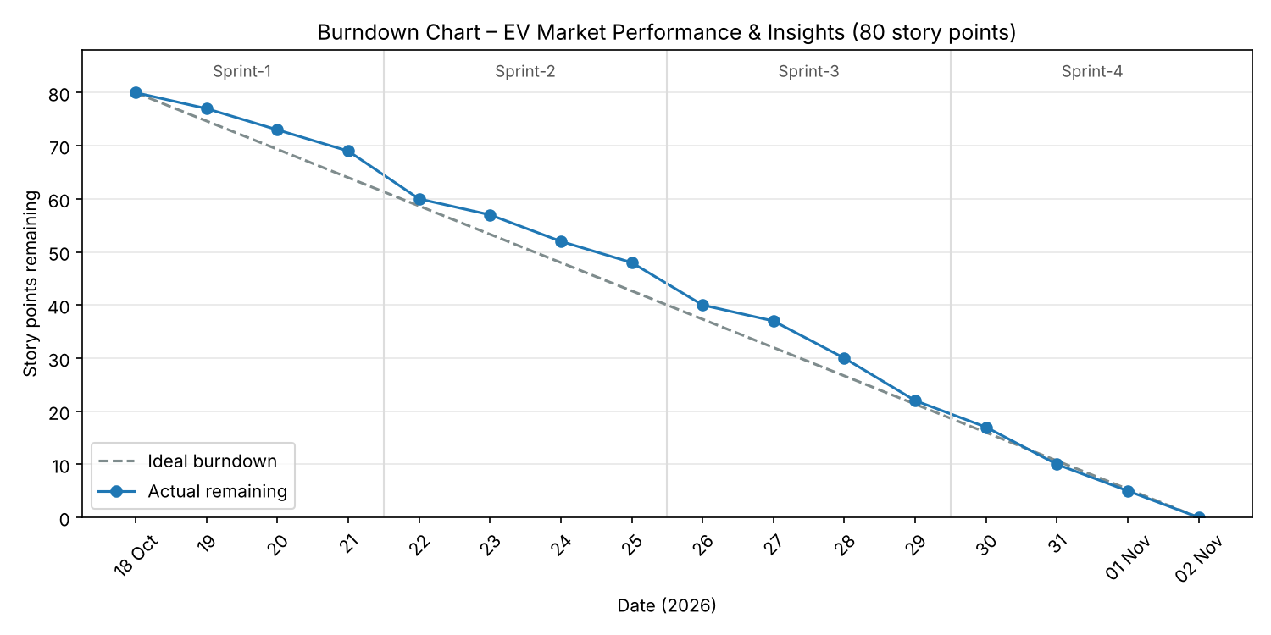

https://www.visual-paradigm.com/scrum/scrum-burndown-chart/
https://www.atlassian.com/agile/tutorials/burndown-charts

Reference:
https://www.atlassian.com/agile/project-management
https://www.atlassian.com/agile/tutorials/how-to-do-scrum-with-jira-software
https://www.atlassian.com/agile/tutorials/epics
https://www.atlassian.com/agile/tutorials/sprints
https://www.atlassian.com/agile/project-management/estimation
https://www.atlassian.com/agile/tutorials/burndown-charts

